Lesson 08 Demo 1
Kubernetes Installation and Cluster Setup

Objective: To install Kubernetes and set up a Kubernetes cluster.

Tools required: Docker, Kubernetes.

Pre-requisites: You need to have Docker installed in order to proceed with this demo. If you don’t have it installed, refer to Demo 1 of Lesson 8.

Steps to be followed:
- Installing Kubernetes
- Setting up a Kubernetes cluster

Step 1: Installing Kubernetes
- To download and add the key to allow kubernetes installation, execute the commands mentioned below:
sudo su
curl -s https://packages.cloud.google.com/apt/doc/apt-key.gpg | apt-key add -
sudo echo deb http://apt.kubernetes.io/ kubernetes-xenial main > /etc/apt/sources.list.d/kubernetes.list
- Update the apt-get package by executing the command mentioned below:
sudo apt-get update

- Install the kubernetes and the tools required to manage it. Run the command mentioned below in the terminal:
sudo apt install docker.io kubectl=1.20.5-00 kubeadm=1.20.5-00 kubelet=1.20.5-00

Step 2: Setting up a Kubernetes cluster
- Update the apt-get package by executing the command mentioned below:
sudo apt-get update

- To initialize the cluster run the following command on the master node
sudo kubeadm init
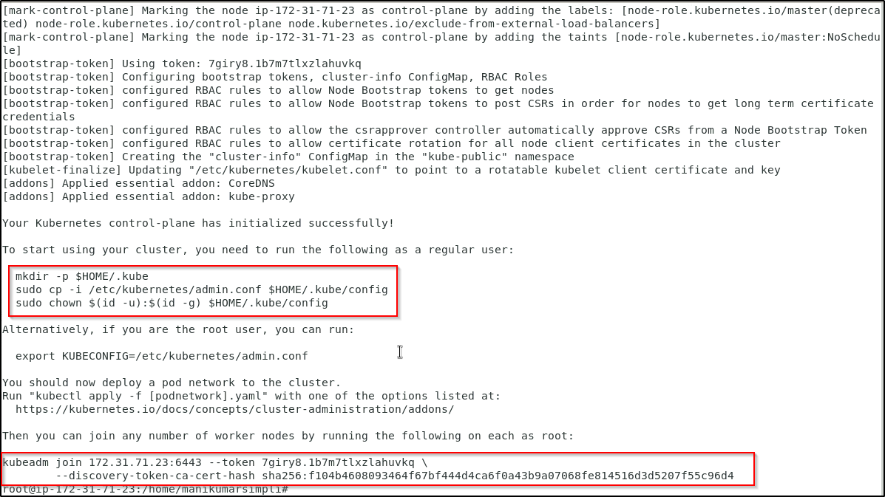
- To start using your cluster, you need to run the following on master node:
mkdir -p $HOME/.kube
sudo cp -i /etc/kubernetes/admin.conf $HOME/.kube/config
sudo chown $(id -u):$(id -g) $HOME/.kube/config

- You should see a single master node deployed on running the command:
sudo kubectl get nodes
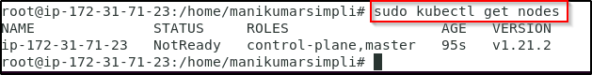

- Copy the kubeadm join command that you can see on the screen of your master node
Note: The command kubeadm join appears after running sudo kubeadm init command and runs with a unique token.

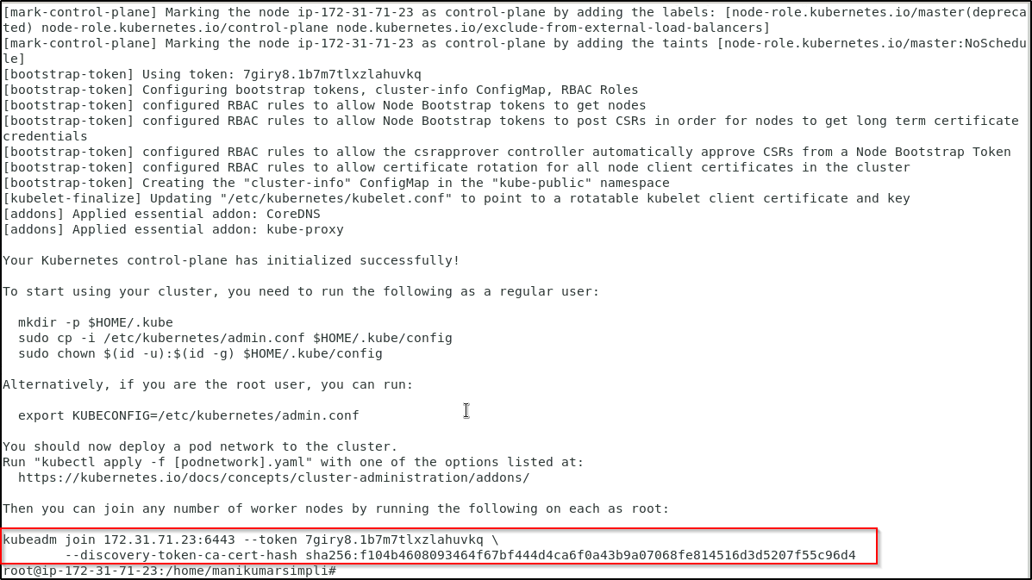

- Run the copied kubeadm join command as a root user on the worker node. You can use the terminal only lab as a worker node. Make sure you have Kubernetes installed on the worker node and then run the below command.
kubeadm join 172.31.64.38:6443 --token 425qb8.51rbrxc5h862g202 \
--discovery-token-ca-cert-hash sha256:a502867d97b05820f186e3ee748afddd9142aae4104aee804d30662148138bae
Note: This is only a sample kubeadm join command. In case you need to find your unique token, run the command sudo kubeadm token create --print-join-command

- On the master node, run the following command to install the weavenet plugin in order to create a network:
kubectl apply -f "https://cloud.weave.works/k8s/net?k8s-version=$(kubectl version | base64 |tr -d '\n')"
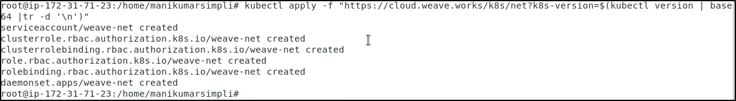
- List all the nodes again to check the status of nodes using the command:
kubectl get nodes
